IRF20/3774

Planning and Assessment
Site inspection report
LGA | Coffs Harbour City
PPA | Coffs Harbour City Council
NAME | Site compatibility certificate, Mullaway Drive, Mullaway
NUMBER | SCC2020COFFS-1
Introduction
Departmental officers carried out a site inspection on 26 August 2020 at 31 Whitton Place, Mullaway and surrounding environment. Map 1 shows photo points for each of the figures.
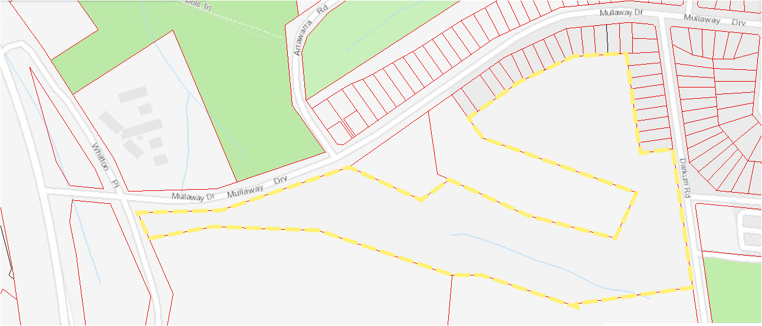
9 & 10
7 & 8
Subject site
House
Insert: Map 2
1
5 & 6
4
2 & 3

Map 1: Photo locality map with view paths of each figure location.
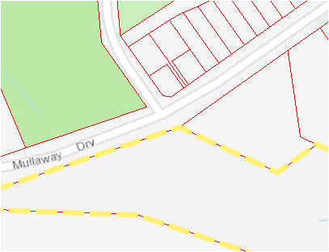
16
17
15
13 &14
11 & 12
Map 2: Photo locality map with view paths at the Mullaway Drive and Arrawarra Road intersection
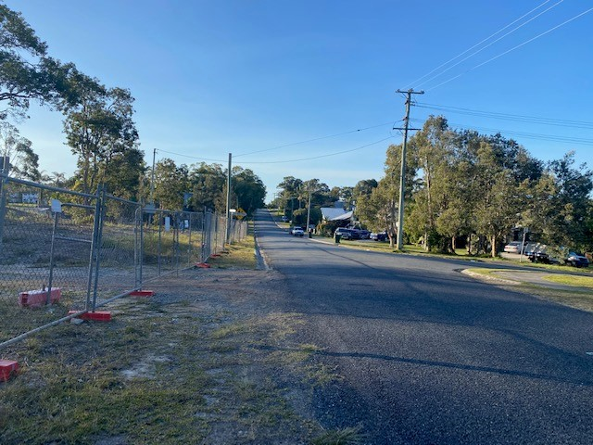
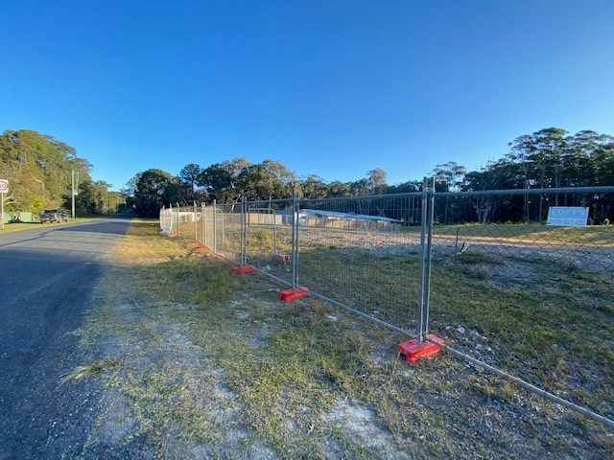
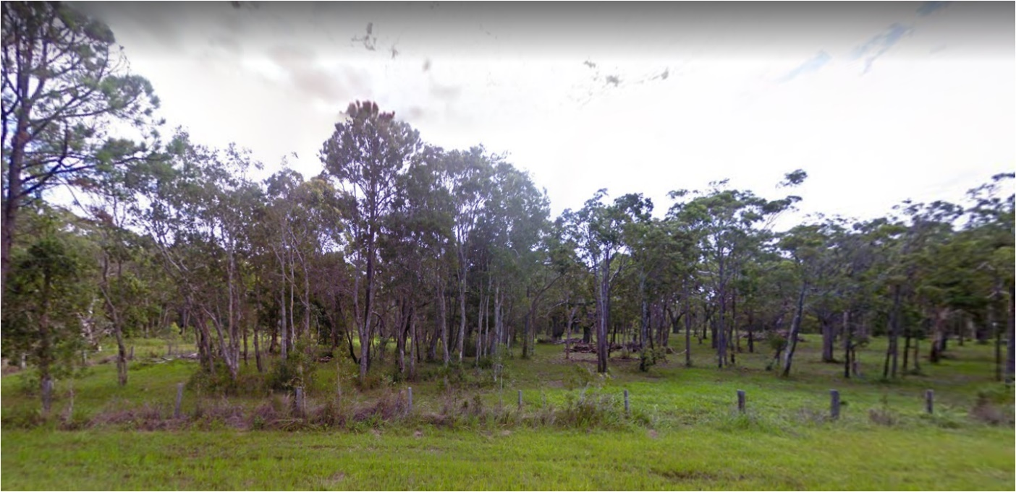
Figure 1 – Darkum Road part street frontage (Southern end)
Figure 2 and 3 – Darkum Road site frontage looking south and north
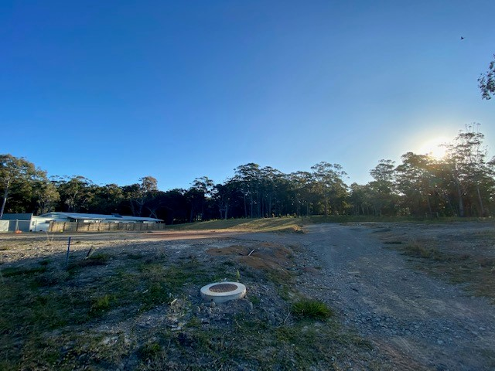
Figure 4 – Cleared land and independent villa Darkum Road frontage
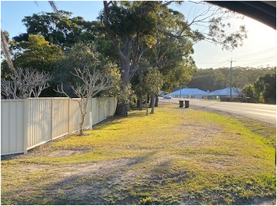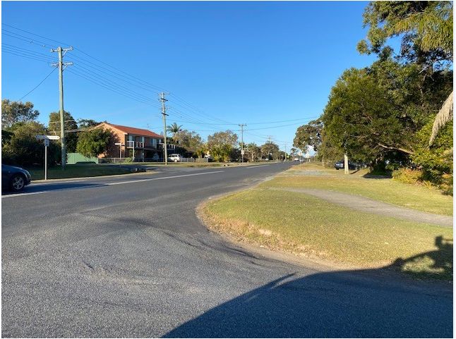
Figure 5 and 6 – Intersection of Darkum Rd and Mullaway Dr, looking west and east along Mullway Dr.
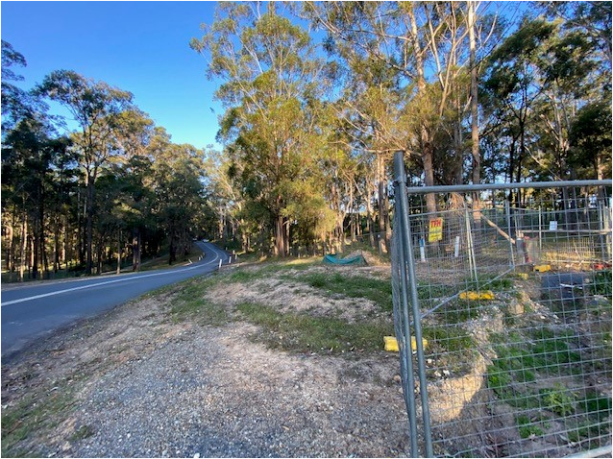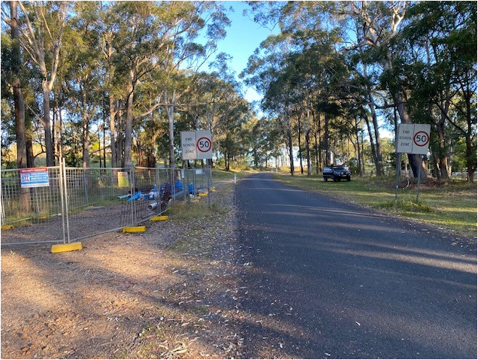
Figure7 and 8 – Corner of Whitton Place and Mullaway Drive. Looking east along Mullway Drive and south along Whitton Place.
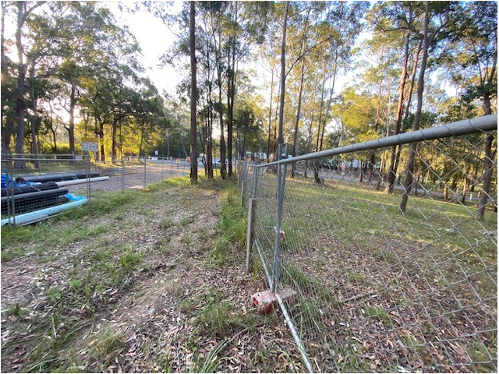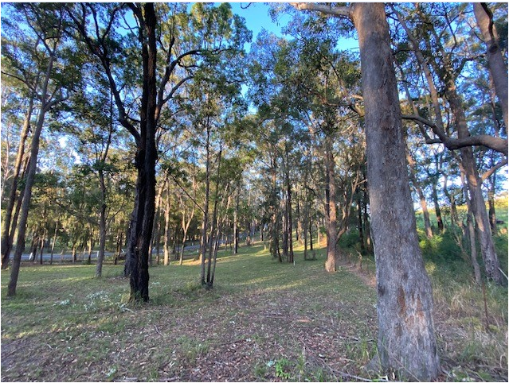
Figure 9 and 10 – Whitton Place site frontage looking north and along the southern boundary of the site.

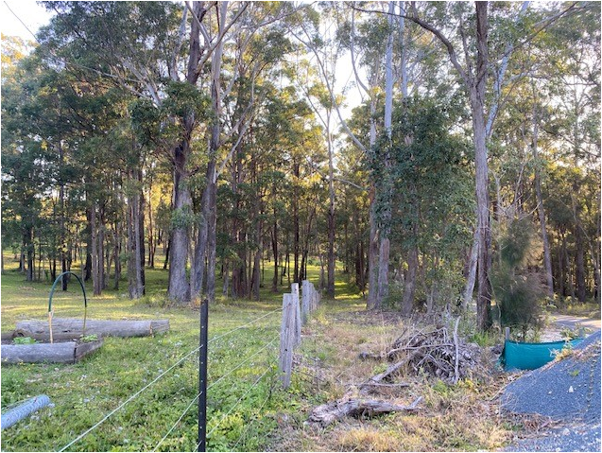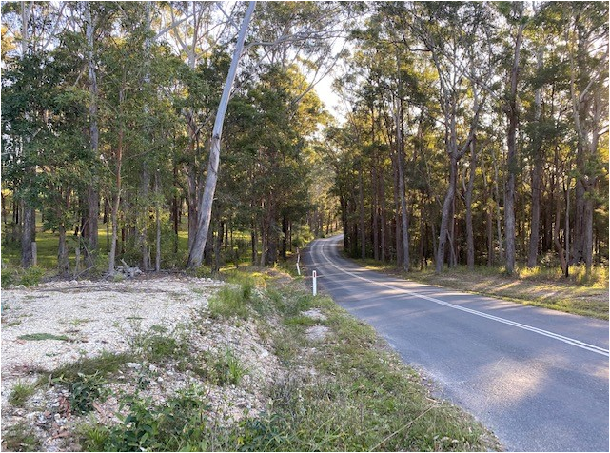
Figure 11 and 12 – Mullaway Dr frontage looking west
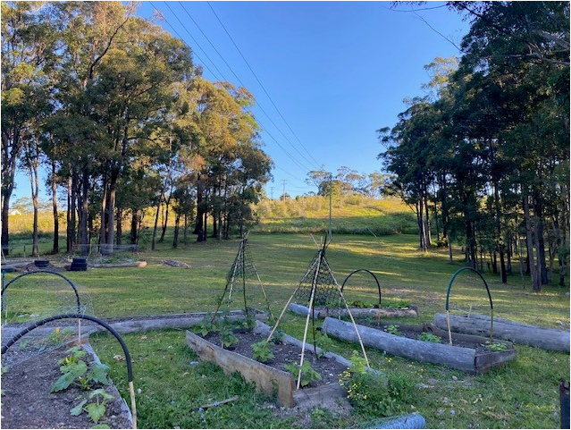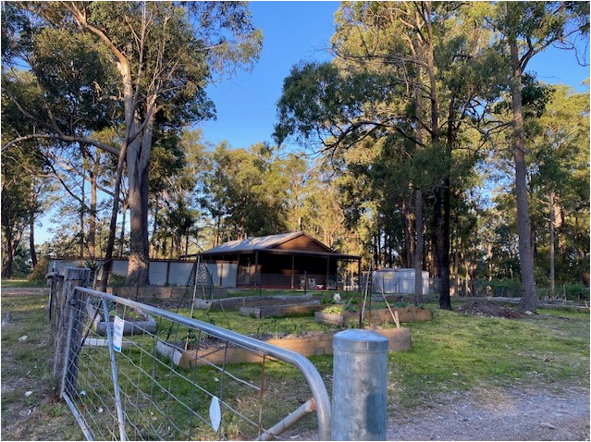
Figure 13 and 14 – Subject site and house fronting Mullaway Dr
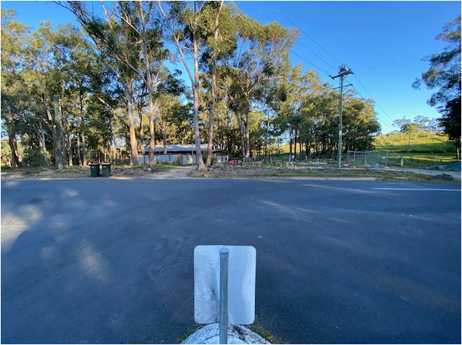
Figure 15 - Mullaway Dr and Arrawarra Road intersection looking from Arrawarra Road to the site frontage
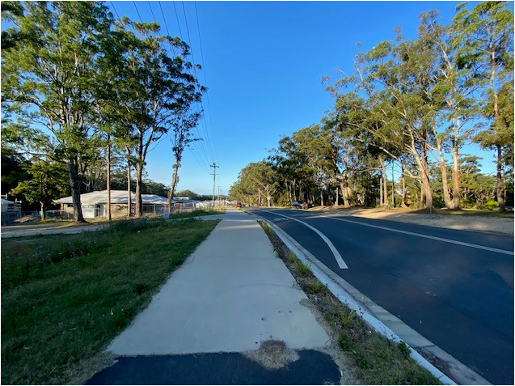
Figure 16 – Looking east along Mullaway Dr on the opposite side of the road to the site
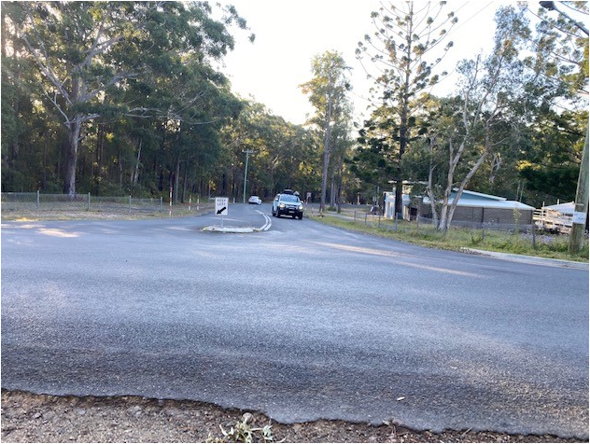
Figure 17 – Mullaway Dr and Arrawarra Road intersection looking from site frontage along Arrawarra Rd.
.

Contact Officer: Rebecca Carpenter
Planning Officer, Northern
Phone: 6643 6421

